Report on Bastacoala Open Cast Project (OCP), Dhanbad

Overview:

Bastacoala Open Cast Project (OCP), located in Dhanbad, is a prominent coal mining operation managed by BCCL (Bharat Coking Coal Limited). The project encompasses both historical underground mining operations and current open-cast mining activities. Here’s a detailed analysis based on the provided information:

1. Mining Operations:

- ROM (Run of Mine) Coal: Bastacoala OCP extracts ROM coal directly from the mines. This coal is unprocessed.

- Depth: The mining operations extend to a depth of 110 meters, indicating significant underground and surface extraction activities.

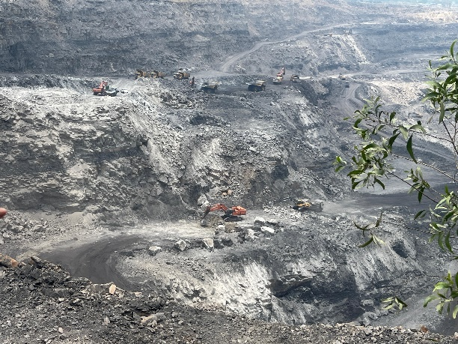

2. Equipment and Machinery:

- Mobile Coal Crusher Machine: This crucial equipment processes sized coal (minus 200mm) at a rate of 250 cubic meters per hour. It features a dual monitoring system (Diesel and Electric) and has a hopper capacity of 3 cubic meters.

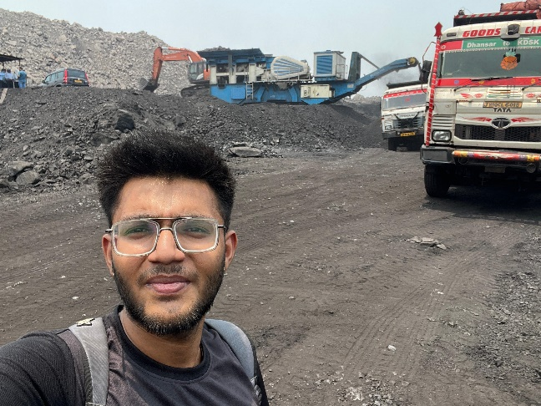

- Dozers: The project employs three types of dozers with varying power capacities (85 hp, 155 hp, and 355 hp). These machines are essential for pushing coal and overburden, levelling surfaces, and maintaining operational efficiency.

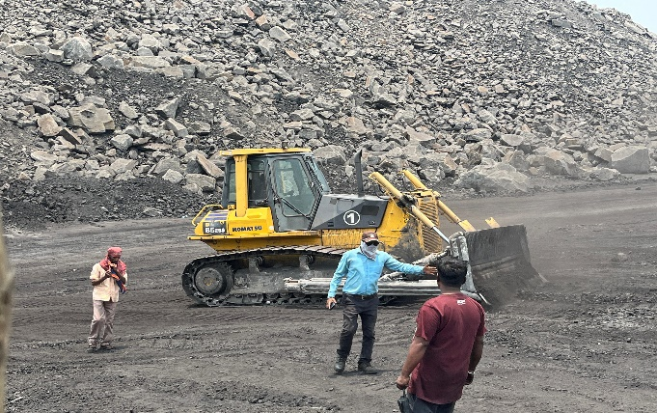

- Shovels: There are 11 shovels in operation, equipped with buckets of 4.5 cubic meters and 2.5 cubic meters capacity. Shovels are instrumental in excavating coal and overburden, facilitating efficient material handling within the mine.

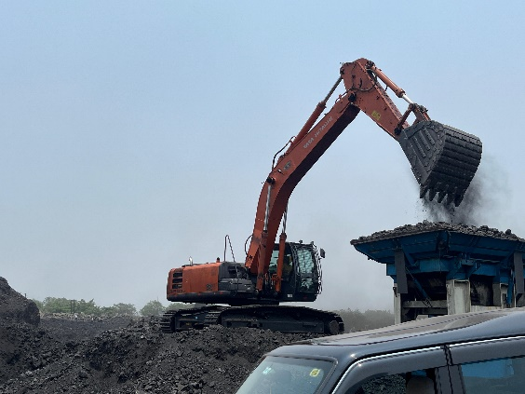

-Haul Road Sprayer : A haul road sprayer in mines refers to a specialized piece of equipment used for dust suppression and road maintenance within mining operations. Here's a detailed explanation. The primary purpose of a haul road sprayer is to control dust generated by vehicles traveling on unpaved haul roads within the mining site. Dust suppression is crucial in mining operations to improve air quality, reduce health risks to workers, and mitigate environmental impacts.

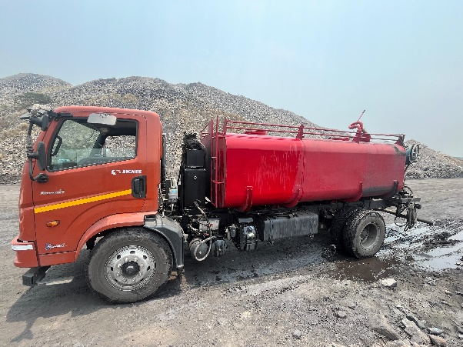

3. Material Handling:

- Cycle Time: The cycle time for each dumper, from loading to unloading, is between 10 to 15 minutes. This efficiency metric is crucial for maintaining continuous operations and optimizing productivity.

- Rehandling: Overburden rehandling involves filling excavated areas within the mine, ensuring operational safety and site stability.

4. Dumping and Storage:

- Overburden Dumps: Bastacoala OCP has four designated dumps for overburden disposal. Currently, two dumps are active, where overburden material is deposited after extraction to manage site logistics effectively.

5. Safety and Monitoring:

- Monitoring Systems: The crusher machine is equipped with a two-way monitoring system, enhancing operational safety and efficiency by allowing real-time monitoring of diesel and electric operations.

6. Geological Context:

- CMPDL - GSI: The project's geological survey and resource estimation are likely facilitated by CMPDL, ensuring strategic planning and resource management based on Geological Survey of India (GSI) data.

7. Production:

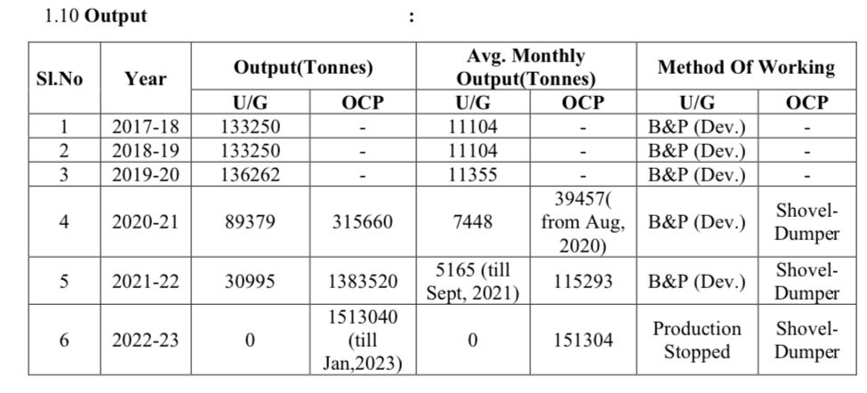

8. Drilling And Blasting

• Drilling **Specifications:**

* **Drill Type:** Rotary or percussion drills capable of drilling to a depth of 6 meters.
* **Drill Pattern:** Combination of staggered and triangular pattern.
  + **Burden:** 3 meters (distance between adjacent holes in a row).
  + **Spacing:** 4 meters (distance between rows of holes).
* **Stemming:** 2 meters of inert stemming material (such as crushed stone or clay) used to confine the explosive charge within the drill hole.

• Blasting **Specifications:**

* **Explosives Type:** Site-mix slurry explosives, formulated on-site to meet the specific requirements of coal mining.
  + **Ingredients:** Typically includes ammonium nitrate, fuel oil (ANFO), and sensitizers as per the site’s formulation standards.

9. Conclusion:

Bastacoala Open Cast Project exemplifies modern mining practices with a blend of historical underground mining and current open-cast operations. The utilization of advanced equipment, efficient material handling processes, and robust safety measures underscores BCCL’s commitment to sustainable and productive mining practices in the region.

This report provides a comprehensive overview of the key operational aspects and equipment specifications at Bastacoala OCP, highlighting its significance within the coal mining sector in Dhanbad.

10. Acknowledgement

I would like to express my gratitude to the entire BCCL team for their support and guidance. Special thanks to Ajay Kumar Sir (Manager), Vinod Raj Sir (Safety Officer) for their mentorship and invaluable insights during the training period.

MADE BY: Poras Singh Rajpurohit

Made through hands on experience during the vocational training period at the mines.